**Date: 16/05/2023(Kubernetes tasks)**

**1.Installing EKS Cluster using Eksctl**

* First Create an IAM user and Create security credentials(secret key & secret access key)
* Install aws-cli and configure aws configure
* Install Kubectl
* **curl -LO "https://dl.k8s.io/release/$(curl -L -s https://dl.k8s.io/release/stable.txt)/bin/linux/amd64/kubectl"**
* **sudo install -o root -g root -m 0755 kubectl /usr/local/bin/kubectl**
* **chmod +xkubectl**
* **kubectl version**
* Install Eksctl
* To download the latest release, run:

# for ARM systems, set ARCH to: `arm64`, `armv6` or `armv7`

ARCH=amd64

PLATFORM=$(uname -s)_$ARCH

curl -sLO "https://github.com/weaveworks/eksctl/releases/latest/download/eksctl_$PLATFORM.tar.gz"

# (Optional) Verify checksum

curl -sL "https://github.com/weaveworks/eksctl/releases/latest/download/eksctl_checksums.txt" | grep $PLATFORM | sha256sum --check

tar -xzf eksctl_$PLATFORM.tar.gz -C /tmp && rm eksctl_$PLATFORM.tar.gz

sudo mv /tmp/eksctl /usr/local/bin

* 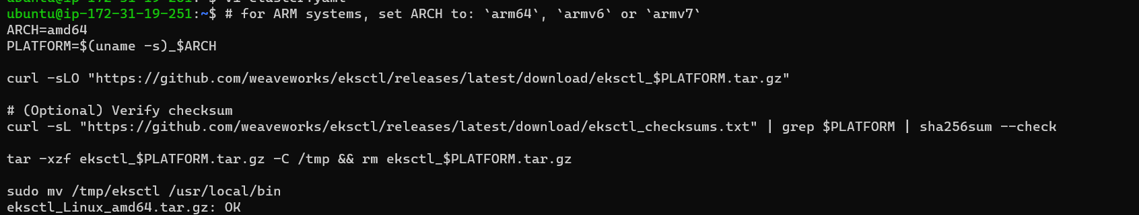

To see the version **eksctl version**

* Create a manifest yaml as cluster.yaml

apiVersion: eksctl.io/v1alpha5

kind: ClusterConfig

metadata:

name: eks-cluster

region: us-east-1

nodeGroups:

- name: ng-1

instanceType: t2.medium

desiredCapacity: 2

volumeSize: 20

ssh:

allow: true # will use ~/.ssh/id_rsa.pub as the default ssh key

* Before applying cluster.yaml generate **ssh-keygen** then apply.
* 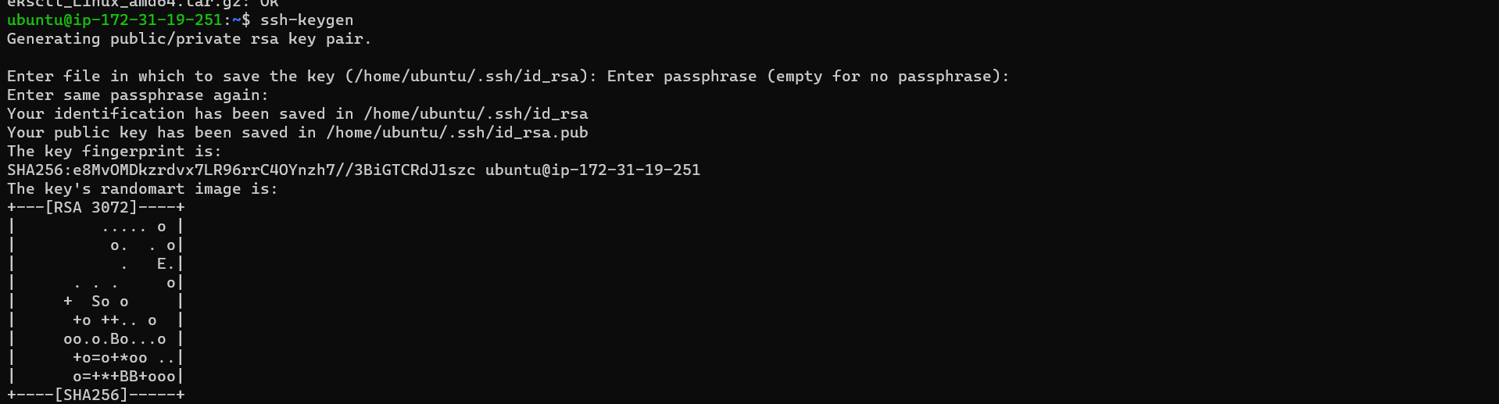
* To see the versions of above
* 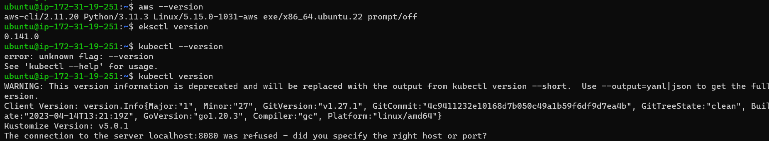
* To create an cluster, run: eksctl create cluster -f cluster.yaml

apiVersion: eksctl.io/v1alpha5

kind: ClusterConfig

metadata:

name: eks-cluster

region: us-east-1

nodeGroups:

- name: ng-1

instanceType: t2.medium

desiredCapacity: 2

volumeSize: 20

ssh:

allow: true # will use ~/.ssh/id_rsa.pub as the default ssh key

* 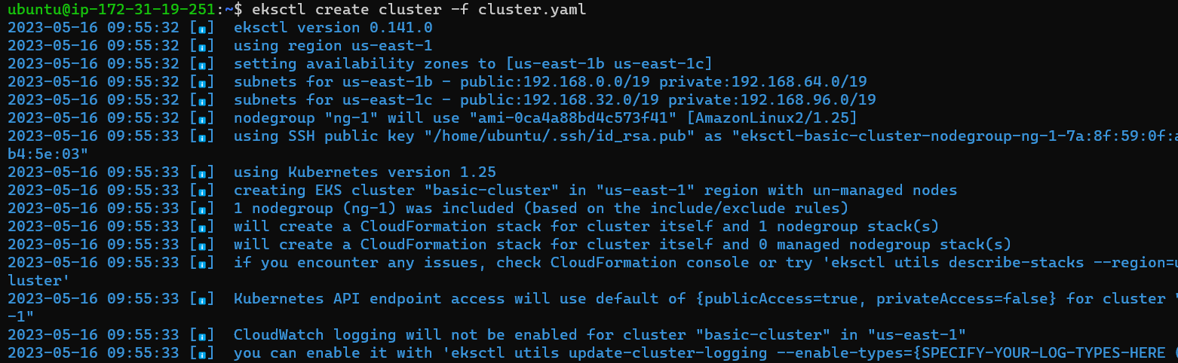
* Cluster will be created after 20mins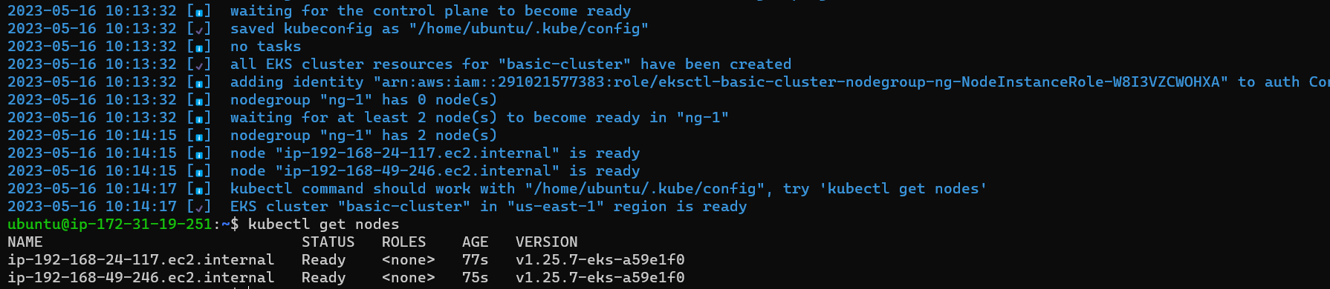

**2.Installations using helm chart**

* First install helm chart in cluster, run:
* **curl -fsSL -o get_helm.sh https://raw.githubusercontent.com/helm/helm/main/scripts/get-helm-3**
* **chmod 700 get_helm.sh**
* **./get_helm.sh**
* 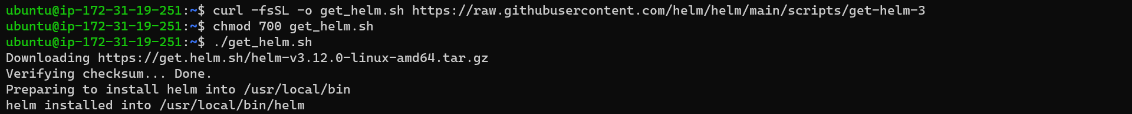

# a. Mysql

* 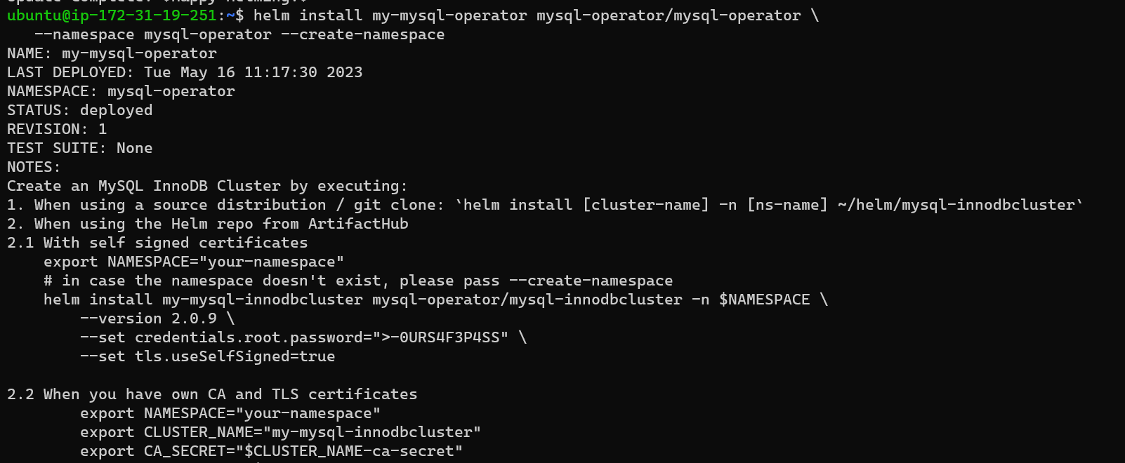
* 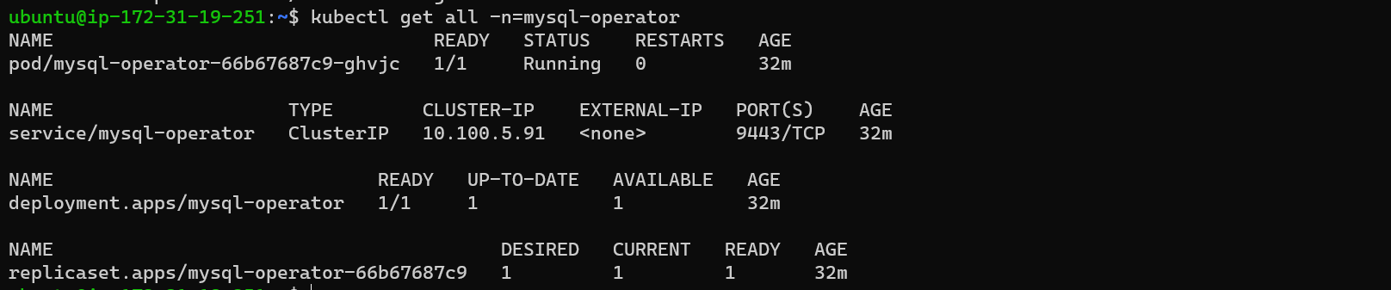
* 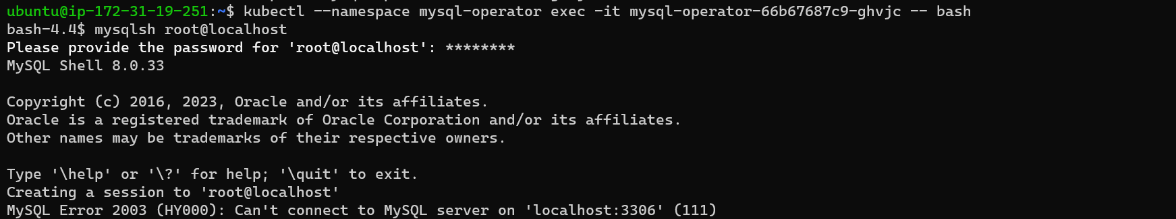

# b. PostgreSql

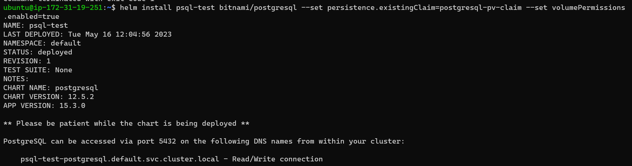

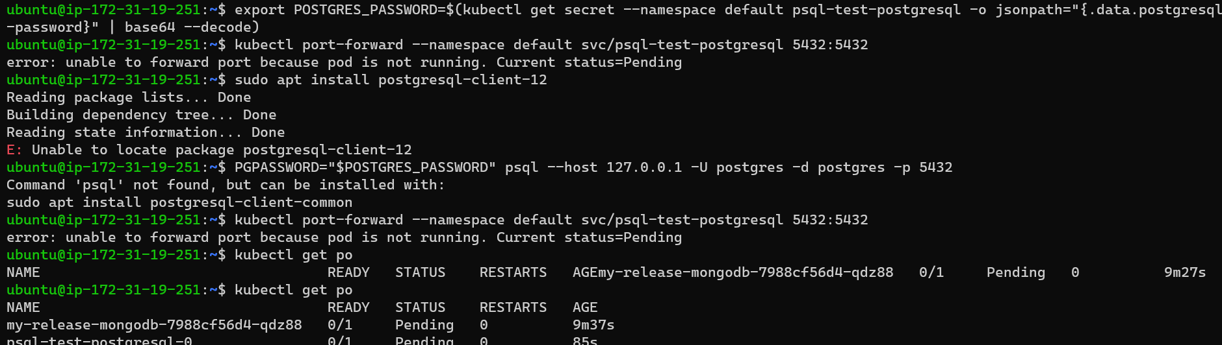

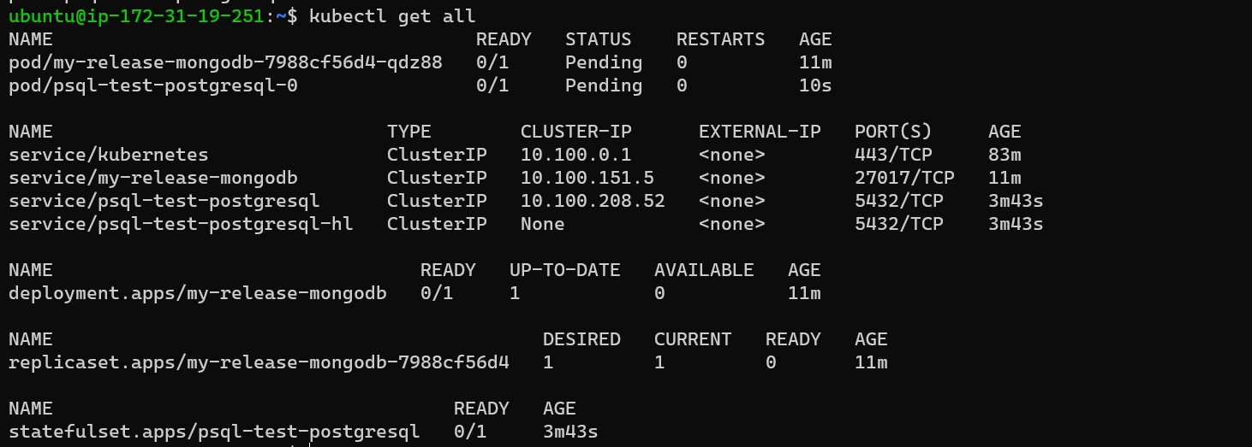

# c.mangodb

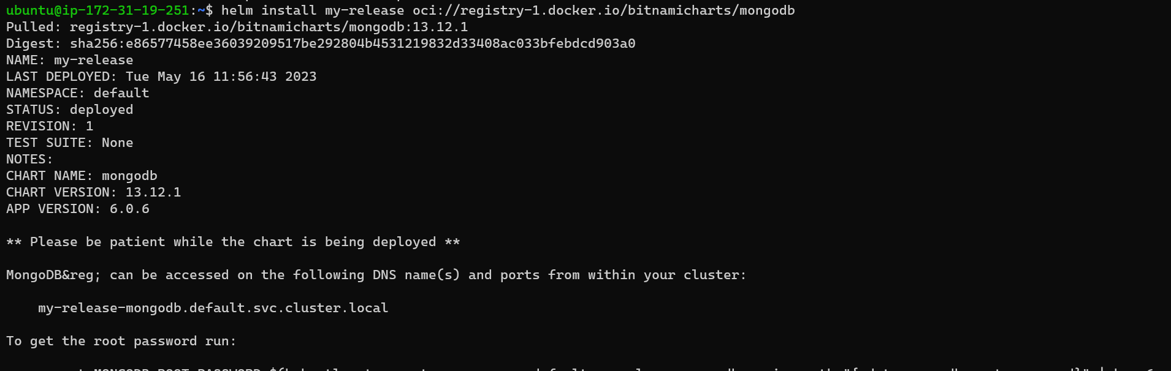

# d. Redis cache

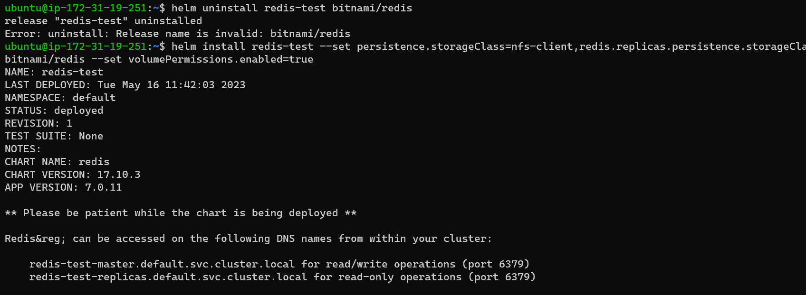

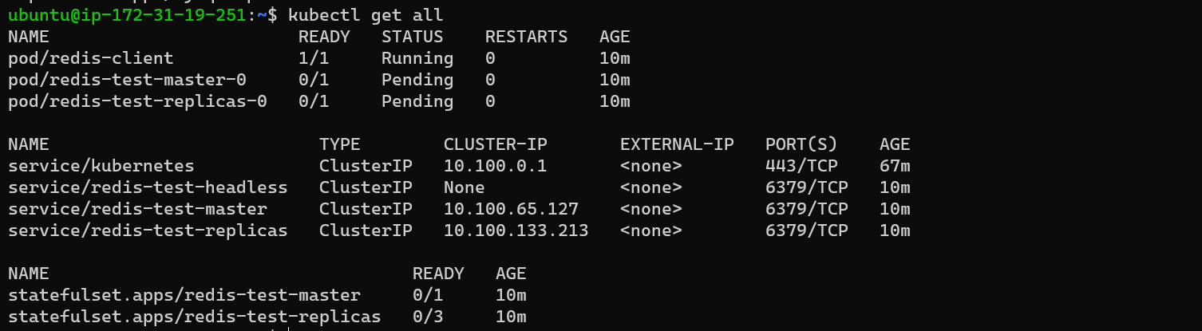

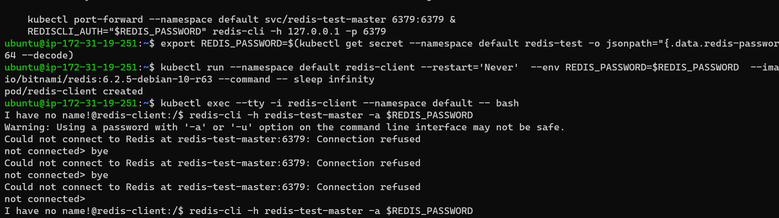

**3. write kostomize file by creating files for 3 environments**

* First create Kustomize file as two directories like base and overlays
  + In bases create main files like deployement.yaml, service.yaml, kustomization.yaml..etc
  + In overlays create multiple environments like DEV, QA, UAT, PROD and create kustomization file in each directory.

# a.dev-environment

**kubectl apply -k ./**

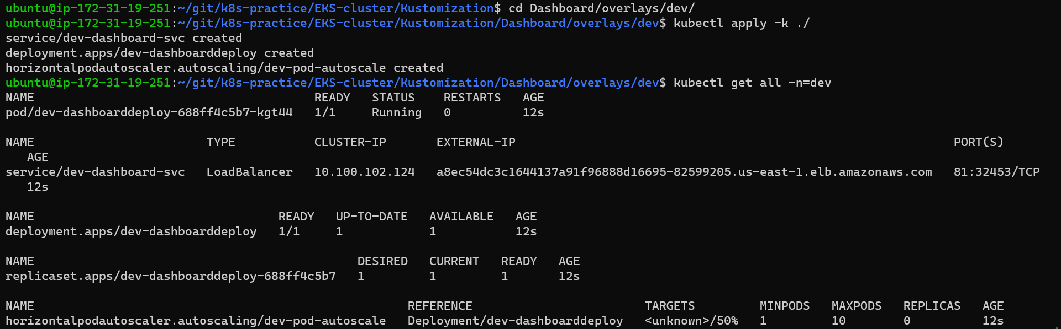

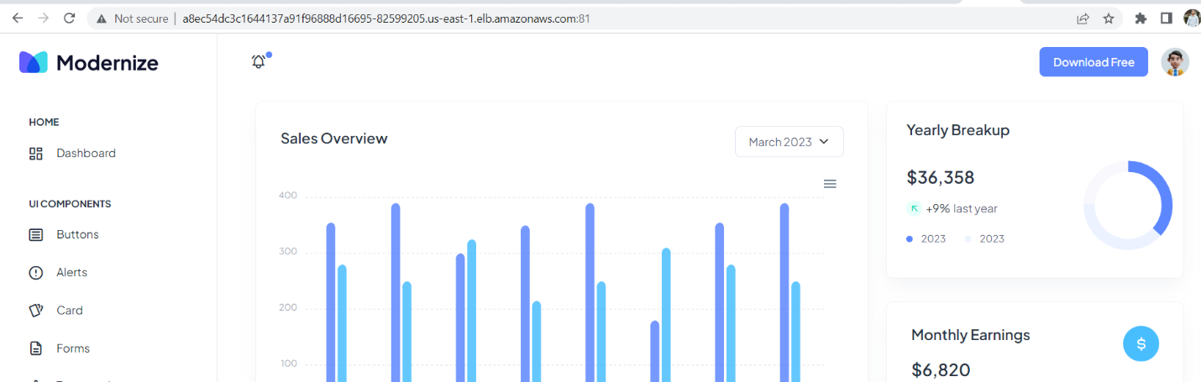

# b.qa-environment

* **kubectl apply -k ../qa/**
* 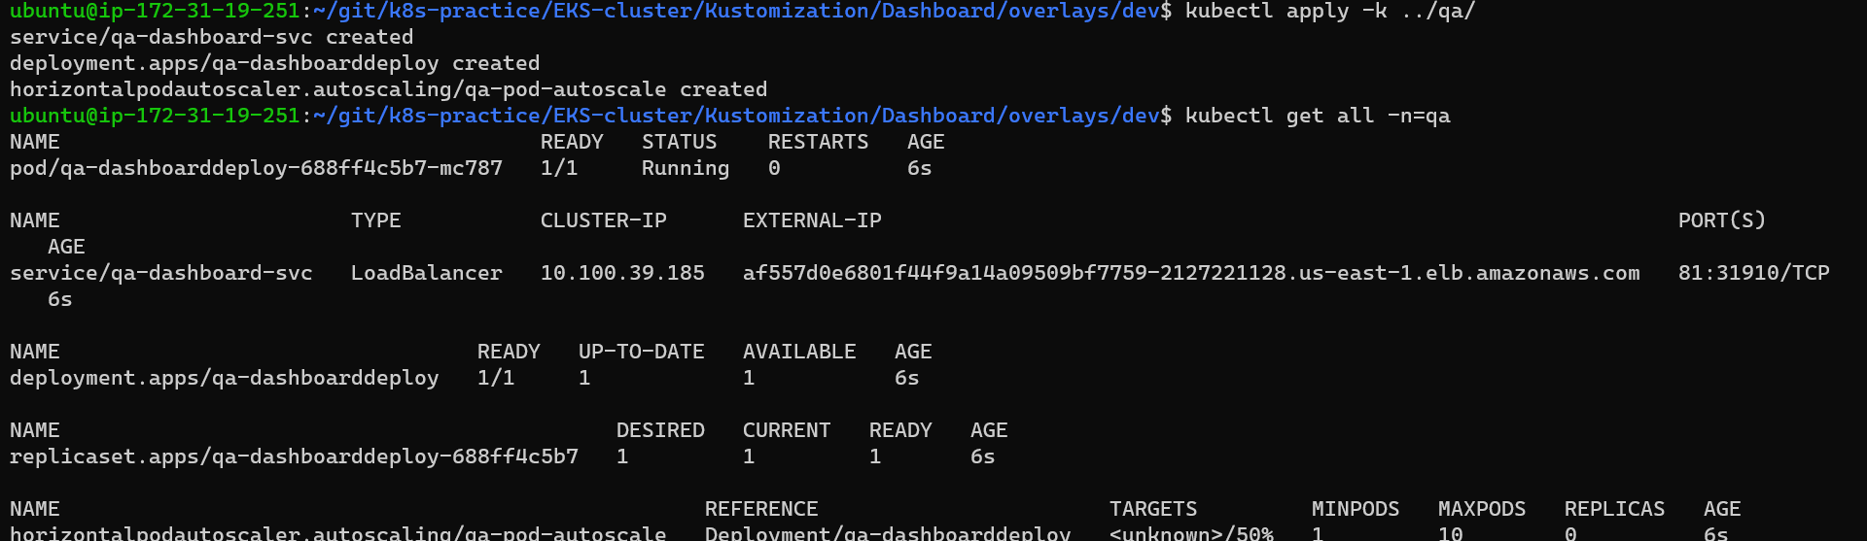

# c.test-environment

* **kubectl apply -k ../uat/**
* 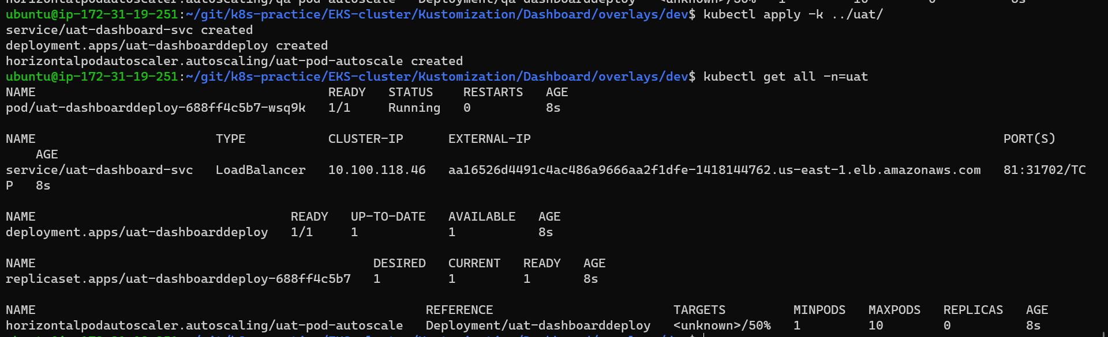

# Every environment should have their own secrets

* **kubectl apply -k ./**
* 
 